***Assignment 3:***

Arjun Patel – FRN006

Q1)Print 1 to 10

*#include*<stdio.h>

int main(){

*// int i=1;*

*// while(i<11){*

*//     printf("%d\n", i);*

*//     i++;*

*// }*

*for* (int i *=* 1; i *<* 11; i*++*)

    {

        printf("%d\n", i);

    }

*return* 0;

}

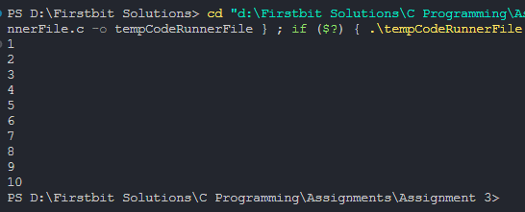

Q2) Print table for the given number.

*#include* <stdio.h>

int main()

{

    int n, i *=* 1;

    printf("Enter Any Number u want to print table of\n");

    scanf("%d", *&*n);

*// while (i < 11)*

*// {*

*//     printf("%d x %d = %d\n", n, i, n * i);*

*//     i++;*

*// }*

*for* (int i *=* 1; i *<=* 10; i*++*)

    {

        printf("%d x %d = %d\n", n, i, n *\** i);

    }

*return* 0;

}

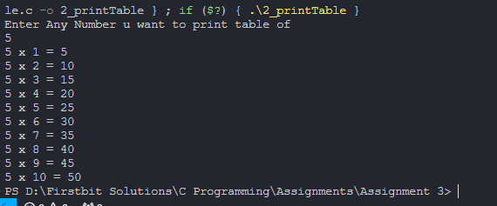

Q3)Calculate sum of numbers in range

*#include*<stdio.h>

int main(){

    int lower, upper, sum*=*0;

    printf("Enter num from which u want sum(Lower limit)\n");

    scanf("%d", *&*lower);

    printf("Enter num to which u want sum(Upper limit)\n");

    scanf("%d", *&*upper);

*// int lowerTemp = lower, upperTemp = upper;*

*// while(lower<=upper){*

*//     sum += lower;*

*//     lower++;2*

*// }*

*for* (int i *=* lower; i *<=* upper; i*++*)

    {

        sum *+=* i;

    }

*// printf("Sum of numbers from %d to %d is %d", lowerTemp, upperTemp, sum);*

    printf("Sum of numbers from %d to %d is %d", lower, upper, sum);

*return* 0;

}

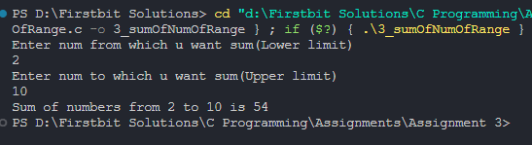

Q4)Check Prime number

*#include* <stdio.h>

int main()

{

    int num, isPrime *=* 1;

    printf("Enter number u want to check prime of\n");

    scanf("%d", *&*num);

*// if num can be divided with 2 to num-1, its not prime*

*// int i = 2;*

*// while (i < num)*

*// {*

*//     if (num % i == 0)*

*//     {*

*//         isPrime = 0;*

*//         break;*

*//     }*

*//     i++;*

*// }*

*for* (int i *=* 2; i*\**i *<=* num; i*++*)

    {

*if* (num *%* i *==* 0)

        {

            isPrime *=* 0;

*break*;

        }

    }

*if* (isPrime)

        printf("%d is a Prime Number\n", num);

*else*

        printf("%d is NOT a Prime Number\n", num);

*return* 0;

}

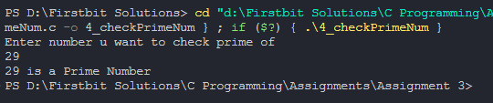

Q5)Check Armstrong Number

*#include* <stdio.h>

*#include* <math.h>

*// if 123 is num, and 1^3 + 2^3 + 3^3 = 123, then its armstrong num*

*//example 153 = 1 + 125+ 27 is armstrong num*

*//1634 = 1^4 + 6^4 + 3^4 + 4^4*

int main()

{

    int num;

    printf("Enter a number:\n");

    scanf("%d", *&*num);

    int temp *=* num, sum *=* 0, count *=*0;

*//find length of number to find exponent*

*while*(temp*>*0){

        count*++*;

        temp */=* 10;

    }

    printf("Count = %d\n", count);

*//temp becomes 0, so ressign for further use*

    temp *=* num;

*while* (temp *>* 0)

    {

        int rem *=* temp *%* 10;

*//cal power of rem*

        int power *=* 1, tempCount *=* count;

*// while(tempCount--){*

*//     power *= rem;*

*// }*

*for* (int i *=* 1; i *<=* tempCount; i*++*)

        {

            power *\*=* rem;

        }

        printf("Power = %d\n", power);

        sum *+=* power;

        temp */=* 10;

    }

    sum *==* num *?* printf("%d is an armstrong number\n", num) *:* printf("%d is not An Armstrong number\n", num);

*return* 0;

}

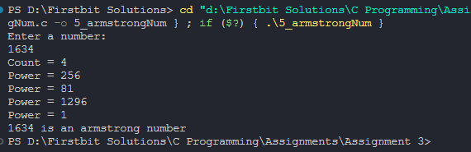

Q6)Perfect Number

*#include*<stdio.h>

*//number can be called perfect if, sum of its divisors is same as number itself*

*//ex: 6 because 1 + 2 + 3 = 6*

*//28 beacuse, 1 +2 + 4 + 7 + 14 =28*

int main(){

    int num;

    printf("Enter a num:\n");

    scanf("%d", *&*num);

    int temp *=* num, sum *=*0;

*// int temp = num, sum =0, divisor=1;*

*// while(divisor<=temp/2){*

*//     if(temp % divisor == 0){*

*//         sum += divisor;*

*//     }*

*//     divisor++;*

*// }*

*for* (int i *=* 1; i *<* temp; i*++*)

    {

*if*(num*%*i*==*0) sum *+=* i;

    }

*if*(temp*==*sum) printf("%d is a Perfect number\n", num);

*else* printf("%s is not a Perfect num\n", num);

*return* 0;

}

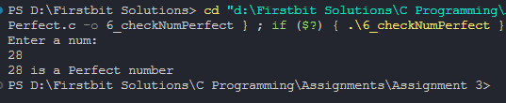

Q7)Find Factorial

*#include*<stdio.h>

int main(){

    int num, fact *=* 1;

    printf("Enter a number:\n");

    scanf("%d", *&*num);

    int temp *=*num;

*// while(num>0){*

*//     fact *=  num;*

*//     num--;*

*// }*

*for*(int i*=*num; i*>*0;i*--*){

        fact *\*=* i;

    }

    printf("%d! = %d",temp, fact);

*return* 0;

}

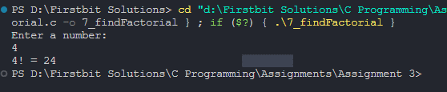

Q8)Strong Number

*#include* <stdio.h>

*// num is called strong if its sum of its digit's factorial is same as num*

*// ex: 145, 1! + 4!+ 5! = 145*

int main()

{

    int num;

    printf("Enter a number:\n");

    scanf("%d", *&*num);

    int temp *=* num, rem, sum *=* 0;

*while* (temp *>* 0)

    {

        rem *=* temp *%* 10;

*//--------Factorial Part-------*

*// find factorial of rem*

        int factorial *=* 1;

*while* (rem *>* 0)

        {

            factorial *\*=* rem;

            rem*--*;

        }

*// add factorial of rem to sum*

        sum *+=* factorial;

*// continue*

        temp */=* 10;

    }

*if* (sum *==* num)

        printf("%d is a Strong Number\n", num);

*else*

        printf("%d is NOT a Strong Number\n", num);

*return* 0;

}

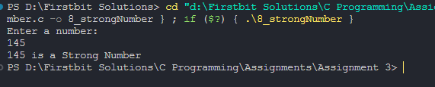

Q9) Palindrome

*#include* <stdio.h>

*// 121, 1331, 12321*

int main()

{

    int num;

    printf("Enter a number:\n");

    scanf("%d", *&*num);

    int temp *=* num, rem, rev *=* 0;

*while* (temp *>* 0)

    {

        rem *=* temp *%* 10;

        rev *=* rev *\** 10 *+* rem;

        temp */=* 10;

    }

*if* (num *==* rev)

        printf("%d is a Palindrome number\n", num);

*else*

        printf("%d is NOT a Palindrome number\n", num);

*return* 0;

}

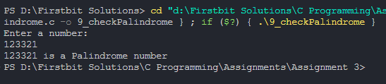

Q10) Summation of first digit and last digit of a number

*#include*<stdio.h>

*#include*<math.h>

*//add first and and last digit of given num*

int main(){

    int num;

    printf("Enter a number:\n");

    scanf("%d", *&*num);

    int temp *=* num, lastDigit, firstDigit, lengthOfNum*=*0;

    lastDigit *=* temp*%*10;

*//logic 1 for find 1st digit of num*

*// while(temp>0){*

*//     lengthOfNum++;*

*//     temp /= 10;*

*// }*

*// //reassign temp to num*

*// temp = num;*

*// firstDigit = temp / pow(10,lengthOfNum-1);*

*//logic 2 for find 1st digit of num*

*while* (temp*>*0)

    {

*// if(temp/10==0){*

*//     firstDigit =temp;*

*//     break;*

*// }*

        firstDigit *=* temp*%*10;

        temp */=* 10;

    }

    printf("Sum of first digit(%d) + last Digit(%d) = %d", firstDigit, lastDigit, firstDigit*+*lastDigit);

*return* 0;

}

